Multifractal DCCA: GBPUSD and NZDUSD
Method 24 / daily log returns / non-overlapping MF-DCCA / Alpari D1 full available history

Study setup
Logical pair: GBPUSD , NZDUSD
Broker symbols: GBPUSD_i , NZDUSD_i
Snapshot: 2026-11-03_majors_alpari_D1
Timeframe: D1
Matched return window: 1999-01-05 to 2026-11-02 (UTC bar dates)
Matched return count n: 7203
Dropped unfinished last bar dated 2026-11-03 UTC after a tick-volume check against the prior complete day.
Scales s in [20, 60, 100]; q in [2.0, 4.0]; headline q=2, s=100
Trend degree=1; overlap=none; positive q only
Complete matched rows (Excel): GBPUSD-NZDUSD_MFDCCA_D1.xlsx
Complete matched rows (HTML table): GBPUSD-NZDUSD_MFDCCA_D1_data.html

Method carried forward
Multifractal DCCA rho_q(s) extends detrended cross-correlation with a positive order q that weights large local fluctuations more strongly. Matched daily log returns of close, ln(close_t / close_t-1), are demeaned and cumulated into profiles. Non-overlapping windows of length s receive a degree-1 local detrend. In each window v, c_xy,v = mean(X_tilde * Y_tilde), c_xx,v = mean(X_tilde^2), c_yy,v = mean(Y_tilde^2). Then G(q,s) = mean_v[ sign(c) * |c|^(q/2) ] and rho_q(s) = G_xy / sqrt(G_xx * G_yy). Positive q only; q=2 recovers the DCCA-type average of c_v. Scales s in {20, 60, 100}; q in {2, 4}; headline q=2, s=100. Same-sample Pearson r is a side check only. This is not causation and not a trading signal.

Results (headline)
rho_q(q=2,s=100): 0.574754
rho_q(q=4,s=100): 0.488386
rho_q(q=2,s=20): 0.545413
rho_q(q=2,s=60): 0.525431
Pearson r: 0.530079

Scale / q summary
q | s | rho_q | n_windows
2 | 20 | 0.54541301 | 360
4 | 20 | 0.40244483 | 360
2 | 60 | 0.52543136 | 120
4 | 60 | 0.35707491 | 120
2 | 100 | 0.57475412 | 72
4 | 100 | 0.4883859 | 72

Conclusion
Headline rho_q(q=2,s=100) for GBPUSD and NZDUSD: 0.5748. At q=4,s=100: 0.4884. At q=2,s=20: 0.5454; q=2,s=60: 0.5254. Pearson r = 0.5301. This is q-weighted detrended linkage, not a trading signal.

Charts
Daily closes

Daily log returns

rho_q versus s
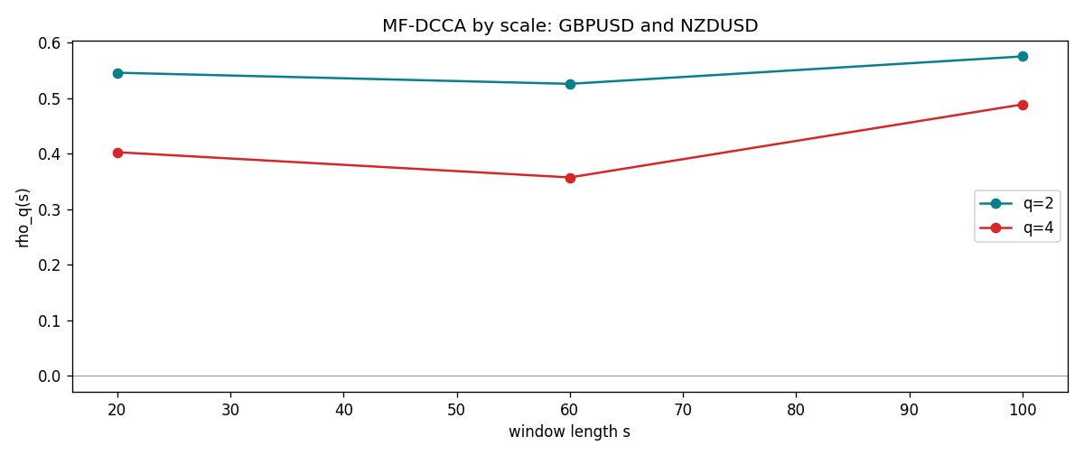

Data report
Matched rows and the scale sheet are in the sibling Excel workbook named GBPUSD-NZDUSD_MFDCCA_D1.xlsx. Embedding all rows as a Word table is impractical; this file holds column summaries and the first and last 15 matched rows.
Columns: time, GBPUSD_open, NZDUSD_open, GBPUSD_high, NZDUSD_high, GBPUSD_low, NZDUSD_low, GBPUSD_close, NZDUSD_close, GBPUSD_tick_volume, NZDUSD_tick_volume, GBPUSD_spread, NZDUSD_spread, GBPUSD_real_volume, NZDUSD_real_volume, GBPUSD_log_return, NZDUSD_log_return
Column summaries (matched calculation rows)
column | count | mean | std | min | 25% | 50% | 75% | max
GBPUSD_open | 7203 | 1.5160351 | 0.21820856 | 1.06854 | 1.32502 | 1.51126 | 1.63163 | 2.1066
NZDUSD_open | 7203 | 0.65617721 | 0.10827592 | 0.3913 | 0.59107 | 0.6683 | 0.72469 | 0.88218
GBPUSD_high | 7203 | 1.5223294 | 0.21877071 | 1.08366 | 1.3298 | 1.51797 | 1.63833 | 2.1161
NZDUSD_high | 7203 | 0.66009189 | 0.10877133 | 0.3961 | 0.594565 | 0.67188 | 0.729235 | 0.88421
GBPUSD_low | 7203 | 1.5097156 | 0.21743942 | 1.03518 | 1.319525 | 1.50315 | 1.62431 | 2.0983
NZDUSD_low | 7203 | 0.65248767 | 0.1078698 | 0.3897 | 0.587935 | 0.66402 | 0.72082 | 0.87988
GBPUSD_close | 7203 | 1.5161019 | 0.21816437 | 1.06879 | 1.32515 | 1.51122 | 1.63196 | 2.1065
NZDUSD_close | 7203 | 0.65624807 | 0.10827144 | 0.3907 | 0.591395 | 0.6683 | 0.724915 | 0.8822
GBPUSD_tick_volume | 7203 | 94800.961 | 153533.35 | 62 | 9991 | 52873 | 91772.5 | 1273370
NZDUSD_tick_volume | 7203 | 68552.383 | 123030.52 | 16 | 5500.5 | 33815 | 58467.5 | 1127682
GBPUSD_spread | 7203 | 26.976121 | 19.194852 | 0 | 11 | 20 | 50 | 50
NZDUSD_spread | 7203 | 30.373178 | 25.676979 | 0 | 9 | 17 | 50 | 80
GBPUSD_real_volume | 7203 | 3.5551025e+09 | 8.4426509e+10 | 0 | 0 | 0 | 0 | 2.4038164e+12
NZDUSD_real_volume | 7203 | 1.6657093e+10 | 8.4881524e+10 | 0 | 0 | 0 | 0 | 2.705649e+12
GBPUSD_log_return | 7203 | -2.372e-05 | 0.00564203 | -0.08388241 | -0.00312422 | 3.221e-05 | 0.0031735 | 0.03112653
NZDUSD_log_return | 7203 | 5.29e-06 | 0.00764545 | -0.07027433 | -0.00426254 | 0.00021291 | 0.00457891 | 0.05966839
First 15 matched rows (selected columns)
time | GBPUSD_log_return | NZDUSD_log_return
1999-01-05 | -0.0028966287 | -0.0018597736
1999-01-06 | -0.00060452184 | 0.0020455609
1999-01-07 | -0.002118709 | 0.0062963171
1999-01-08 | -0.0058954193 | -0.00055396548
1999-01-11 | -0.0056851331 | 0.010290425
1999-01-12 | 0.0022657001 | -0.0053157489
1999-01-13 | 0.0091330396 | -0.0099742238
1999-01-14 | 0.0019376331 | -0.00018564931
1999-01-15 | -0.0017558204 | -0.00074294208
1999-01-18 | 0.0012112405 | -0.0018597736
1999-01-19 | 0.0018745281 | 0.0018597736
1999-01-20 | -0.0049053846 | 0.0040793678
1999-01-21 | 0.0031518998 | 0.0040627941
1999-01-22 | 0.0024781662 | -0.012051689
1999-01-25 | 0.0012066366 | -0.0035504102
Last 15 matched rows (selected columns)
time | GBPUSD_log_return | NZDUSD_log_return
2026-10-13 | 0.0036434319 | 0.0047326165
2026-10-14 | -0.0049164679 | -0.0037306483
2026-10-15 | 0.0065976411 | 0.0047634855
2026-10-16 | 0.0037592051 | 0.0057501001
2026-10-19 | -0.0017500314 | 0.0018917133
2026-10-20 | 0.0055923442 | 0.0037199341
2026-10-21 | 0.0012476328 | 0.0030923331
2026-10-22 | 0.00022396082 | -0.0033035227
2026-10-23 | -0.0021146949 | 0.0030929853
2026-10-26 | -0.0024340661 | -0.0028993932
2026-10-27 | -0.0023648393 | -0.00026399852
2026-10-28 | 0.0015771808 | -0.0097283914
2026-10-29 | 0.0035881935 | 0.00062190714
2026-10-30 | 0.0013450605 | 0.00019537668
2026-11-02 | 0.0010971256 | -0.0025962955

